**James White : PCA Analysis of Porpiglia Data Set**

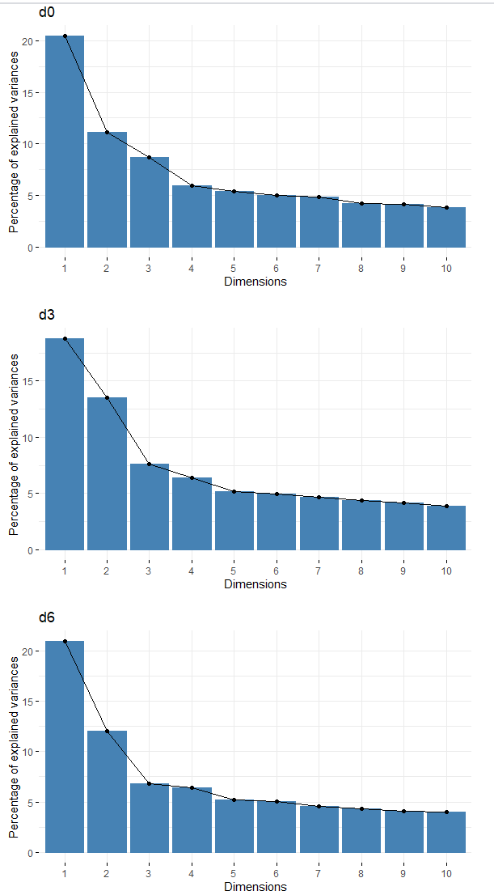

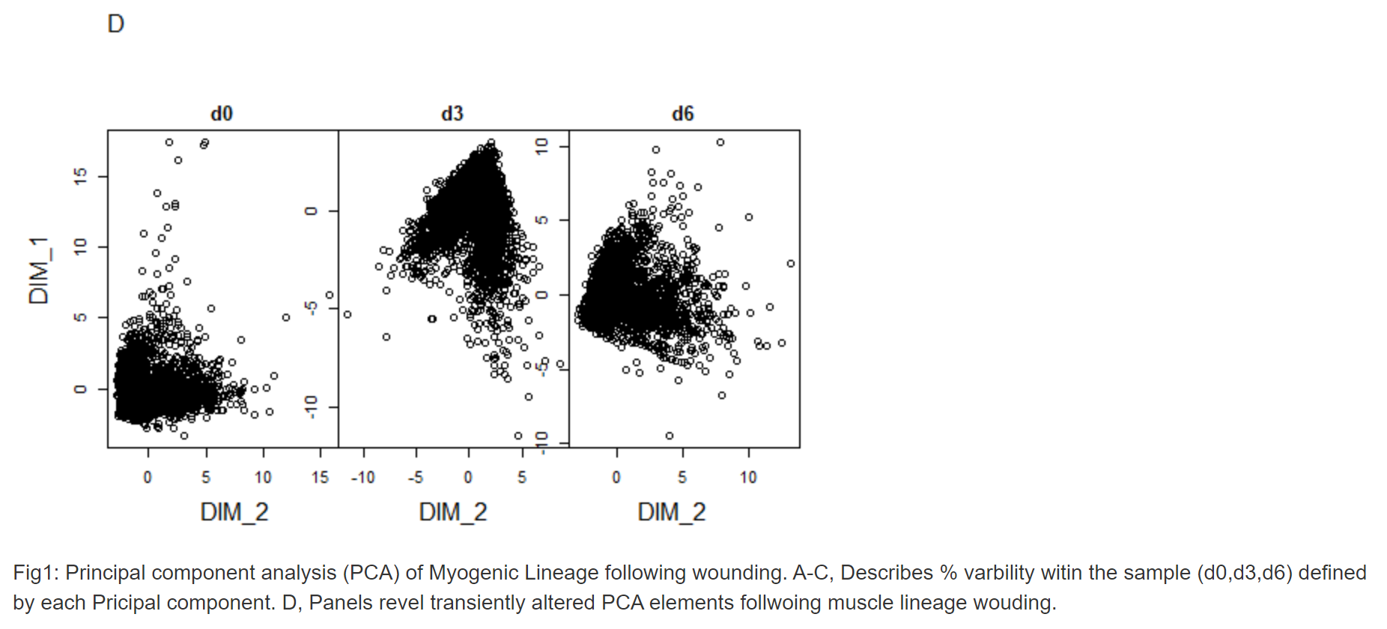

Results: These data reveal the varied Principal Component Analysis across the three sampling days. Fig1a-c indicate that the molecular components driving wounded muscular stem cell population identity varies across the three days sampled. In general, they show that a similar trend exists for d0 and d6, however the PCA identity for d3 varies from the other two days. This indicated that by d3 post wounded the muscle stem cell populations have a different identity from that d0, and by d0 they population has returned to a more normal state.

Discussion: These data are limited primarily by a lack of programming experience by the user. Mainly the output for fig1a-c would be most useful were the PCA components identified in the output of the figure, but how to achieve this output is unknown to this user. Similarly, the output for the dimensions of fig1d-f is lacking due to lack of knowledge of the use. However, this type of data analysis is very powerful, when used correctly. Despite not knowing what dimensions are being reported it is obvious that between d0-d6 a large fate change in the tissue is being undertaken. At d0 the tissue is likely still in its initial re-patterning phase thus wound dependent transcription regulation is not observed. By d3 the wound site has repatterned the tissue, detected by the PCA. Thus the factors that drive the variance in the d3 tissue are quite different from the other days. By d6 the profile of the tissue seems to return to a normal state more similar to d0. It is using these tools wound dependent transcription regulation could be uncovered and explored in greater detail. Further the scope of these experiments and their aim could be tuned to explore different areas depending on the antibodies selected. For instance, as an individual interested in cell cycle regulation following wounding, I would be intrigued to explore how wounding affects transcription cell cycle components such as the cyclins, or their inhibitors. Future I would be interested to determine is wounding drived the induction of endocycling cells, were the wounded cells undergo replication without division. However, these studies fall outside of the scope of this data set.